**What has been Accomplished so far:**

The bugs with Twitter login have finally been worked out and the complete OAuth flow has been written up in Javascript with a PHP backend. The settings and about pages have been integrated into the home screen (see embedded facebook timeline screenshot). Facebook timelines have been rudimentarily implemented and are dynamically filled out (see email for attached video).

**What we are behind on:**

Nothing, we are currently on schedule to complete our project.

**What we are ahead on:**

We are currently on (or ahead of) schedule for completing the backend by the end this week. We are slightly ahead in that we’ve already partially setup the Settings page, which was something planned for the 9th week. Currently, the HTML and CSS have already been completed for it.

**Whats next:**

Next will be implementation of sharing a post to Facebook, implementation of Twitter’s feed using it’s embedded posts, and sharing a post to Twitter. In addition, some minor bugs will be worked out of the Facebook newsfeed implementation.

**Photos:**

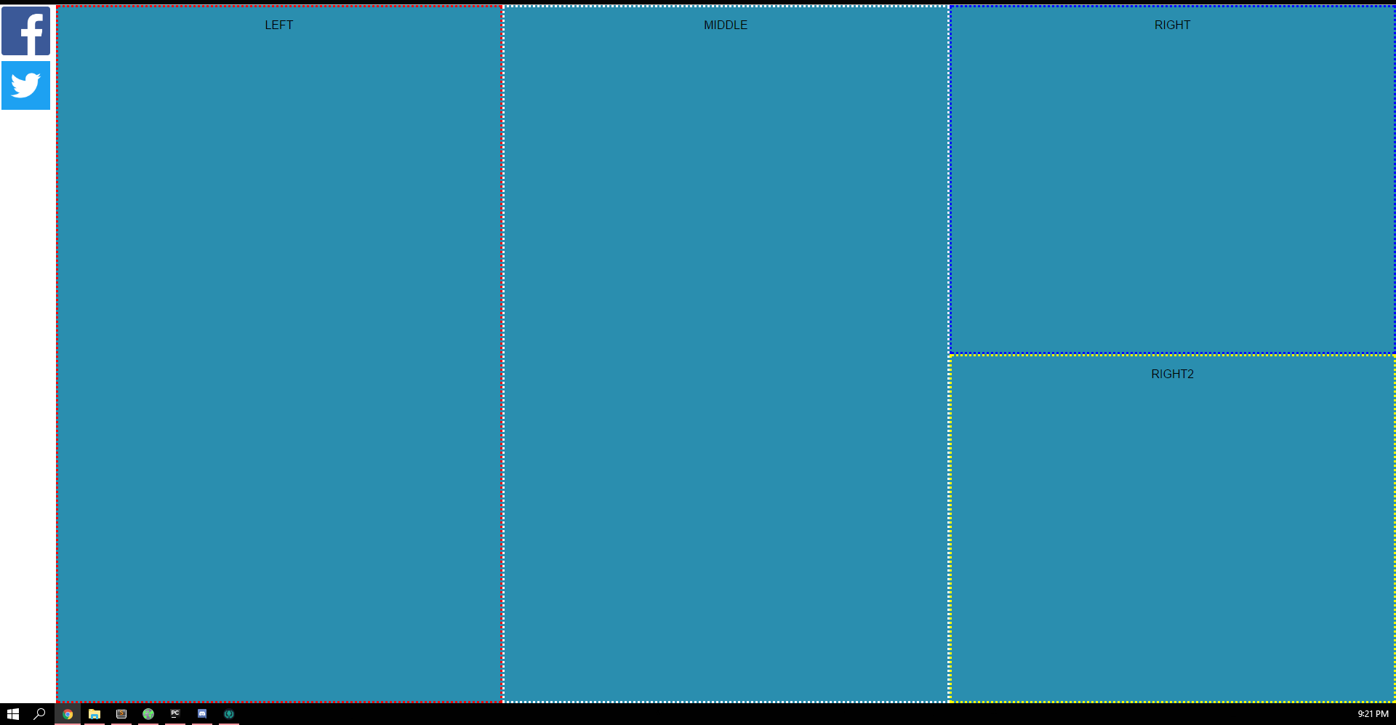

*The Home Page (Borders are just for show)*

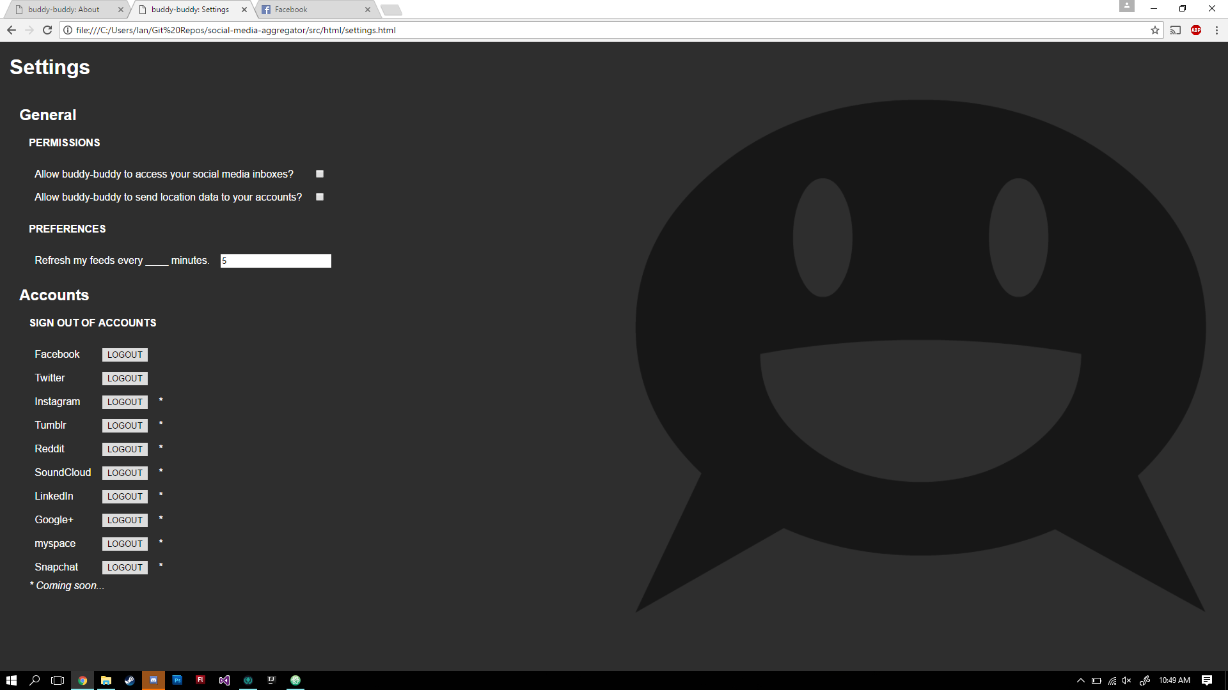

*Settings Page (first draft)*

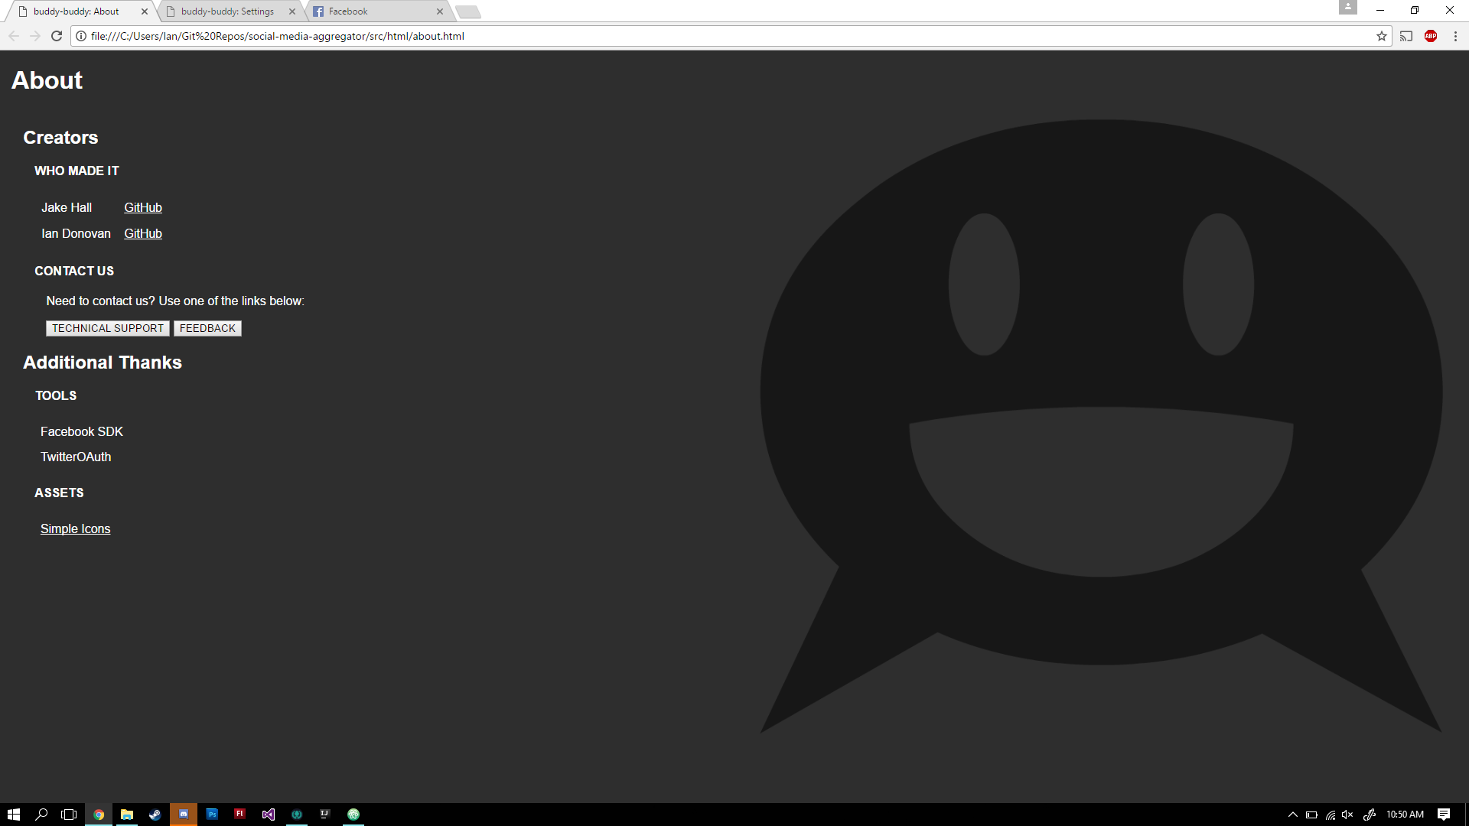

*About Page (first draft)*

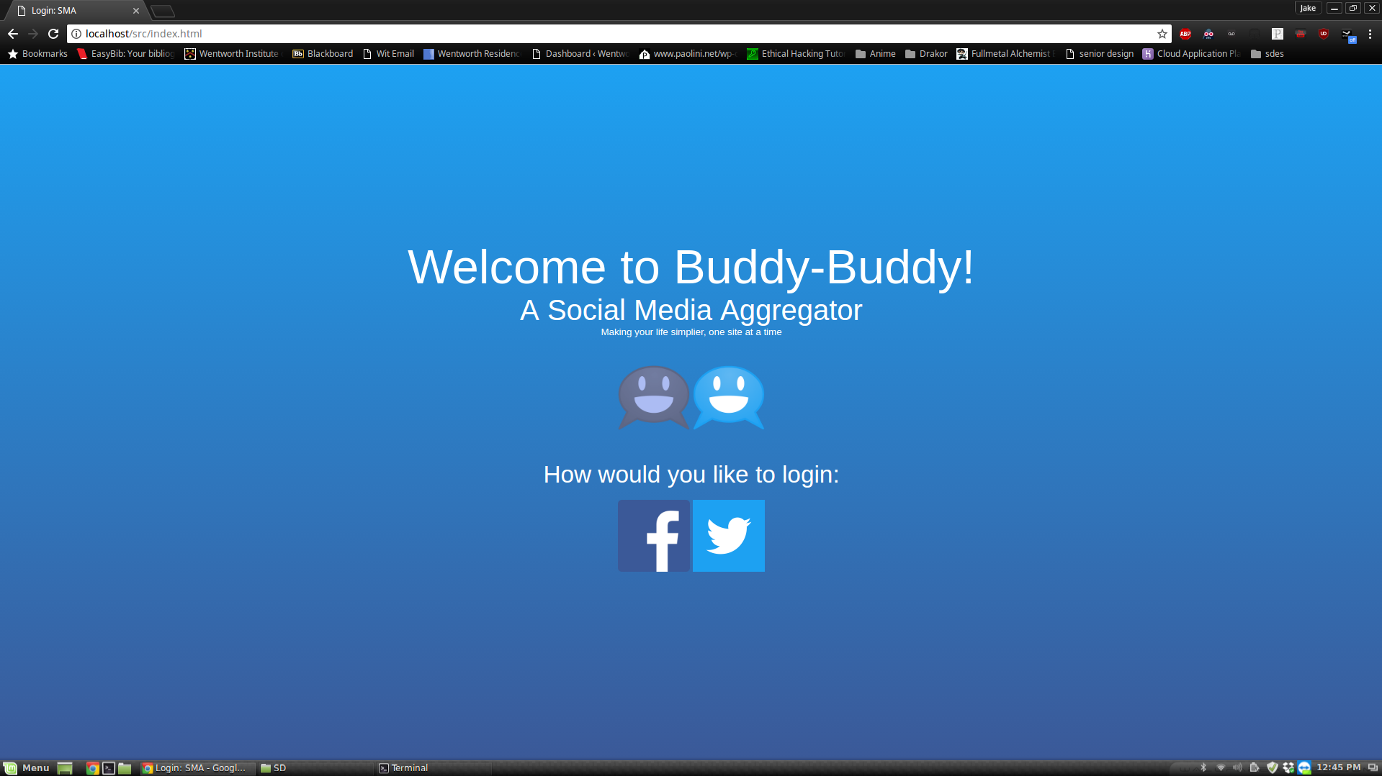

*The General Login Screen*

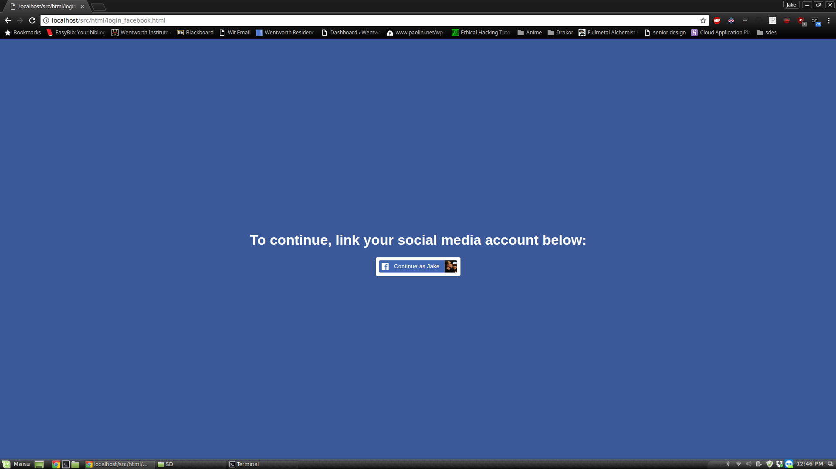

*The Facebook Specific Login Page*

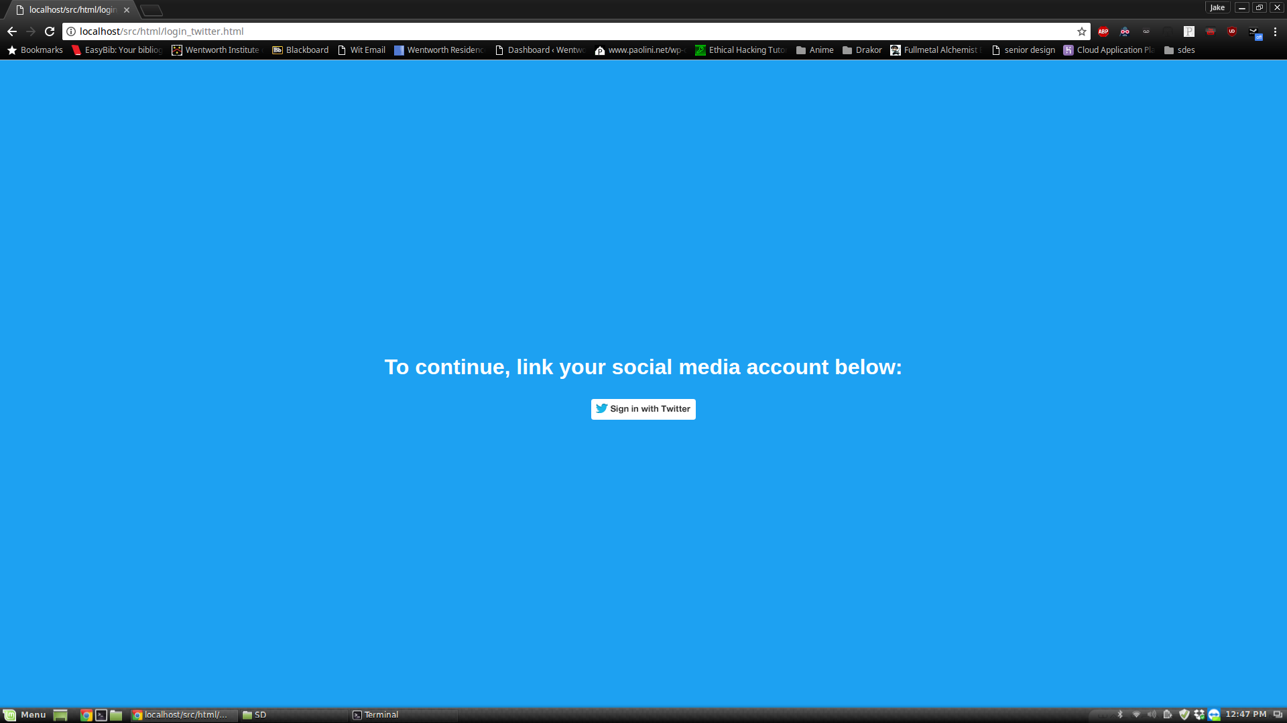

*The Twitter Specific Login Page*

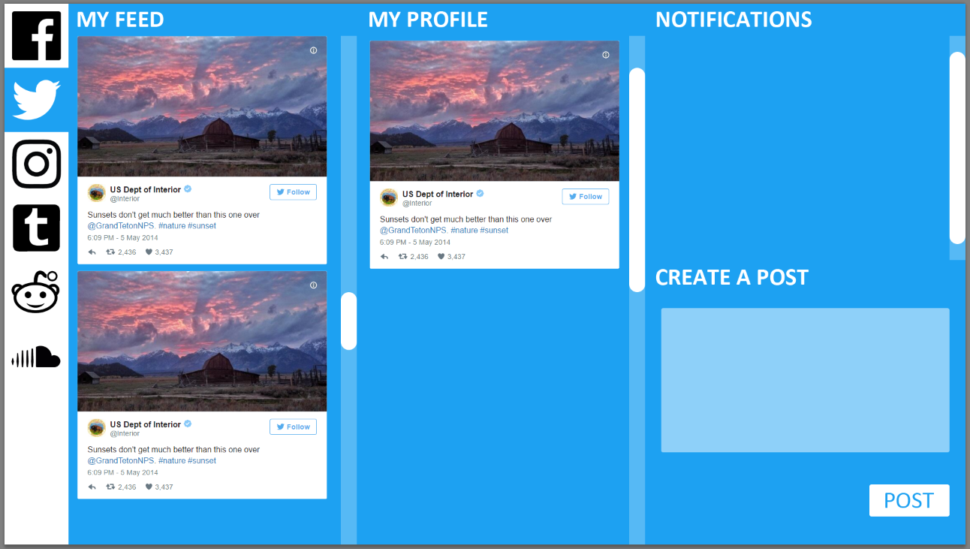

*Twitter Home Screen Mockup*

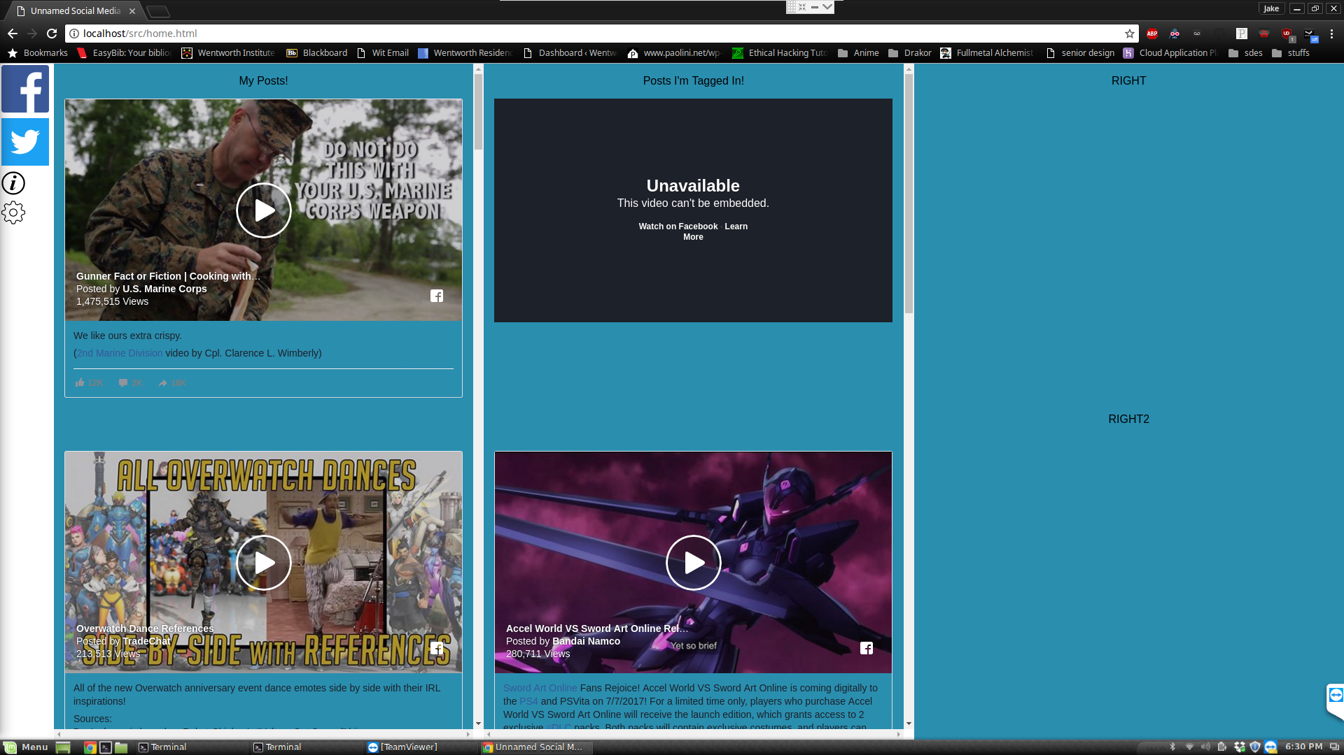

*Embedded facebook timeline*